product lubricated
deep well vertical turbine pump
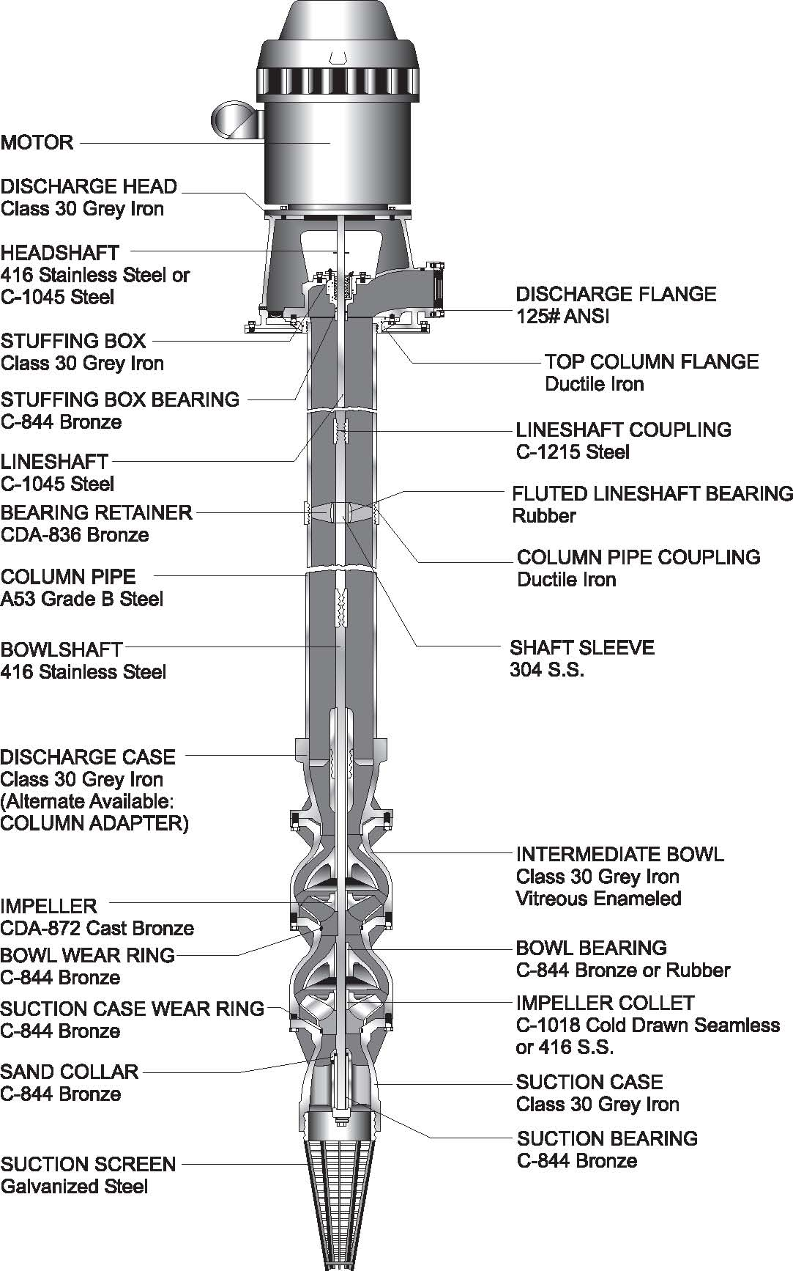
STANDARD PUMP SPECIFICATION
PRODUCT LUBRICATED
DEEP WELL VERTICAL TURBINE PUMP
GENERAL
The contractor shall furnish a deep well product lubricated lineshaft vertical turbine pump, manufactured by NATIONAL PUMP or equal, with above ground discharge and furnished with suitable driver and accessories to meet the requirements herein or as shown on the drawings. The pump shall be designed and furnished to conform to the Hydraulic Institute and AWWA specifications for Lineshaft Turbine Pumps and shall comply with all local and state sanitary and safety regulations.
INFORMATION REQUIRED IN PROPOSAL
1. Data sheet completely filled in.
2. Performance curve showing expected performance at design point. Curve will show head, capacity, efficiency, and horsepower based on bowl performances and shall cover the complete operation range of the pump from zero capacity to the maximum capacity.
3. Drawings of the proposed equipment giving general dimensions sufficient to determine how the equipment is to be supported and if it will fit within the space available.
4. Any additional information such as descriptive literature, manufacturer’s specifications, and other data to demonstrate compliance with these specifications.
CONDITIONS OF SERVICE
Design conditions____________USGPM, @__________feet total dynamic head (TDH), Minimum bowl efficiency ____________%, Overall length, bottom of discharge head to bottom of strainer ____________feet, Well inside diameter____________inches, Maximum allowable speed____________RPM.
PUMP CONSTRUCTION
DISCHARGE HEAD: Shall be of close grained, cast iron ASTM A48 Class 30, or fabricated steel, accurately machined with a rabbet fit for mounting the driver and supporting the pump column assembly and with above ground discharge flange machined and drilled to ANSI standards for _______________# rating and _____________ inches inside diameter. The design shall allow for the headshaft to couple above the stuffing box.
The standard stuffing box shall be cast iron and rated for ___________ discharge pressure and shall contain a minimum of five acrylic graphite packing rings and shall have a grease chamber. The packing gland shall be bronze secured in place with stainless steel studs and adjusting nuts. The stuffing box bearing shall be C-844 bronze. A rubber slinger shall be installed on the top shaft above the packing gland. The top shaft shall be 416 S.S. and shall extend through the stuffing box.
The headshaft shall be C-1045 carbon steel. Impeller adjustment shall be provided at the top of the headshaft by means of an adjusting nut which shall be locked in place.
COLUMN PIPE shall be ASTM A53 grade B steel pipe, sized such that the friction loss will not exceed 5 ft. per 100 ft., based on the rated capacity of the pump and shall weigh not less than ____________ lbs/ft. The column pipe shall be furnished in interchangeable sections not more than (10) ft. in length for 1800 RPM and (5) ft. for 3600 RPM and shall be connected with threaded sleeve type couplings. The ends of each section of column pipe shall be machined with 8 threads per inch with 3/16” taper and faced parallel and the threads machined to such a degree that the ends butt against the bearing retainer shoulder to ensure proper alignment and to secure the bearing retainers when assembled.
NOTE: TOP AND BOTTOM SECTIONS SHALL NOT EXCEED 5 FT. IN LENGTH.
COLUMN ASSEMBLY - PRODUCT LUBRICATED
LINESHAFTS shall be C-1045 turned, ground and polished. They shall be furnished in interchangeable section not over (10) feet in length. The shaft shall be sized in accordance with the maximum recommended horsepower for a given size of shaft, taking into account the effect of the hydraulic thrust on the pumping equipment and the weight of the shaft and suspended rotating parts. To ensure accurate alignment of the shafts, they shall be straight within 0.005 in. total indicator reading for a 10 ft. section. The butting faces shall be machined with center relief and square to the axis of the shaft. The lineshaft shall be provided with 304 stainless steel sleeves at the location of each bearing retainer. The lineshaft shall be coupled with 1215 steel couplings, and shall be held in place by bronze bearing retainers with neoprene bearings at each threaded joint.
BOWL ASSEMBLY
PUMP BOWLS shall be of close grained, cast iron ASTM A48 Class 30 and shall be free of blow holes, sand holes, or other detrimental faults and shall be accurately machined and fitted to close tolerances. The bowls shall have vitreous enamel lined waterways to reduce friction losses and provide a maximum efficiency and wear protection. The intermediate bowls shall be provided with C-844 bronze bearings. The intermediate bowls shall be fitted with replaceable wear rings of bronze C-844.
IMPELLERS shall be of CDA872 cast bronze and shall be enclosed type accurately machined, balanced, and filed for optimum performance. They shall be securely fastened to the shaft with a taper split collet of ____________1215 steel or ____________416 stainless steel.
COLUMN ADAPTER OR DISCHARGE CASE shall be close grained cast iron ASTM A48 class 30, threaded to properly match the discharge column.
SUCTION CASE shall be fitted with replaceable wear ring of bronze C-844, grease packed C-844 bronze bearing and protected by a bronze C-844 sand collar.
BOWL SHAFT shall be ASTM A582 grade 416 stainless steel, turned, ground and polished.
SUCTION PIPE AND STRAINER
The suction pipe shall be ____________ft. in length and of a size and weight at least equal to that of the column pipe. A galvanized steel strainer shall be provided having a net inlet area equal to at least four times the suction pipe area.
MOTOR
The motor shall be squirrel cage induction design, NEMA design B, ____________ RPM vertical hollow shaft motor, with a non-reverse ratchet. Thrust bearing shall be chosen to handle the entire hydraulic thrust load of the pump plus the weight of the rotating parts. With an AFBMA B-10 one year minimum or five year average life under design conditions. The motor shall be premium efficiency with a WP-1 enclosure, 1.15 service factor, for use on _________volt, three phase, 60 cycle electric service. The motor rating shall be such that at design it will not be loaded beyond nameplate rating and at no place on the pump curve shall the loading exceed the service factor.

